# False Positive and False Negative

## 1-True Positive

### What is True Positive

**# Source**: **Chatgpt (GPT-5-Standard) at [8/23/2025]**

A **True Positive** in software testing refers to a situation where the test **correctly identifies a real defect or issue** in the system. It is an accurate detection of a problem.

### **✅ Key Points**

**# Source**: **Chatgpt (GPT-5-Standard) at [8/23/2025]**

* Indicates a **real defect** exists and the test flagged it correctly.
* Represents the **desired outcome** for defect detection.
* Opposite of a **False Positive**.

### **✅ Examples**

**# Source**: **Chatgpt (GPT-5-Standard) at [8/23/2025]**

* A security scanner detects an actual SQL Injection vulnerability.
* A unit test fails because the application logic is genuinely incorrect.
* An automated functional test catches an error in form validation when invalid input is provided.

### **✅ Why It’s Important**

**# Source**: **Chatgpt (GPT-5-Standard) at [8/23/2025]**

* Helps ensure that defects are **found early** and fixed before release.
* Increases **trust in the testing process** and tools.

## 2-True Negative

### What is True Negative

**# Source**: **Chatgpt (GPT-5-Standard) at [8/23/2025]**

A **True Negative** in software testing refers to a situation where the test **correctly identifies that there is no defect**, meaning the system works as expected and the test passes.

### **✅ Key Points**

**# Source**: **Chatgpt (GPT-5-Standard) at [8/23/2025]**

* Indicates the system is **functioning correctly**, and the test confirms it.
* Opposite of **False Negative**.
* Represents the **ideal outcome** for scenarios without issues.

### **✅ Examples**

**# Source**: **Chatgpt (GPT-5-Standard) at [8/23/2025]**

* A login test with valid credentials passes successfully (no defect present).
* A security scan confirms no SQL Injection vulnerability in a properly coded input field.
* A functional test on a feature that works correctly reports **Pass**.

### **✅ Why It’s Important**

**# Source**: **Chatgpt (GPT-5-Standard) at [8/23/2025]**

* Confirms system stability for scenarios with **no defects**.
* Builds confidence in the **accuracy of testing**.

## 3-False Positive

### What is False Positive

**# Source**: **Chatgpt (GPT-5-Standard) at [8/23/2025]**

A **False Positive** in software testing refers to a situation where a **test incorrectly reports a defect or failure when the system is actually working correctly**.

### ✅ Key Points

**# Source**: **Chatgpt (GPT-5-Standard) at [8/23/2025]**

* It is an **incorrect indication of a problem**.
* Happens when the **test case or testing tool flags an issue that does not exist**.
* Common in **automation testing**, static code analysis, and security scans.

### **✅ Causes**

**# Source**: **Chatgpt (GPT-5-Standard) at [8/23/2025]**

* **Incorrect Test Scripts**: Automation scripts not updated for recent changes.
* **Misconfigured Testing Tools**: Tools set with wrong rules or thresholds.
* **Environment Issues**: Test environment not mirroring production properly.
* **Outdated Test Data**: Tests running against old or irrelevant data.

### **✅ Examples**

**# Source**: **Chatgpt (GPT-5-Standard) at [8/23/2025]**

* A security scanner reports SQL Injection vulnerability, but input validation is properly implemented.
* An automated UI test fails because of minor UI element position changes, even though functionality works fine.
* A static code analysis tool flags a safe function call as a potential risk.

### **✅ Impact**

**# Source**: **Chatgpt (GPT-5-Standard) at [8/23/2025]**

* Wastes time investigating non-existent issues.
* Increases **testing effort** and may delay releases.
* Can reduce trust in testing tools if frequent.

## 4-False Negative

### What is False Negative

**# Source**: **Chatgpt (GPT-5-Standard) at [8/23/2025]**

A **False Negative** in software testing refers to a situation where a **test fails to detect an existing defect or issue**, incorrectly indicating that everything is working fine.

### ✅ Key Points

**# Source**: **Chatgpt (GPT-5-Standard) at [8/23/2025]**

* Opposite of **False Positive**.
* Means the test result is **“Pass”** when there is actually a defect.
* Dangerous because defects remain **undetected** and can reach production.

### **✅ Causes**

**# Source**: **Chatgpt (GPT-5-Standard) at [8/23/2025]**

* **Poor Test Coverage**: Important scenarios not included in test cases.
* **Incorrect Test Logic**: Test script does not check the right conditions.
* **Tool Limitations**: Automated tools failing to detect certain vulnerabilities.
* **Incomplete Requirements Understanding**: Missing conditions during test design.

### **✅ Examples**

**# Source**: **Chatgpt (GPT-5-Standard) at [8/23/2025]**

* An automated test reports a “Pass” even though a calculation in the code is incorrect.
* A security scan fails to detect an actual XSS vulnerability.
* A unit test checks only positive scenarios, ignoring edge cases where errors occur.

### **✅ Impact**

**# Source**: **Chatgpt (GPT-5-Standard) at [8/23/2025]**

* Critical defects go **undetected**, causing failures in production.
* Can lead to **security breaches**, financial loss, or system crashes.

## Summary Table

**# Source**: **Chatgpt (GPT-5-Standard) at [8/23/2025]**

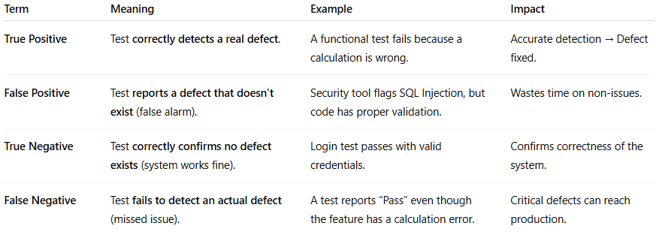

| **Term** | **Meaning** | **Example** | **Impact** |
| --- | --- | --- | --- |
| **True Positive** | Test **correctly detects a real defect**. | A functional test fails because a calculation is wrong. | Accurate detection → Defect fixed. |
| **False Positive** | Test **reports a defect that doesn’t exist** (false alarm). | Security tool flags SQL Injection, but code has proper validation. | Wastes time on non-issues. |
| **True Negative** | Test **correctly confirms no defect exists** (system works fine). | Login test passes with valid credentials. | Confirms correctness of the system. |
| **False Negative** | Test **fails to detect an actual defect** (missed issue). | A test reports “Pass” even though the feature has a calculation error. | Critical defects can reach production. |